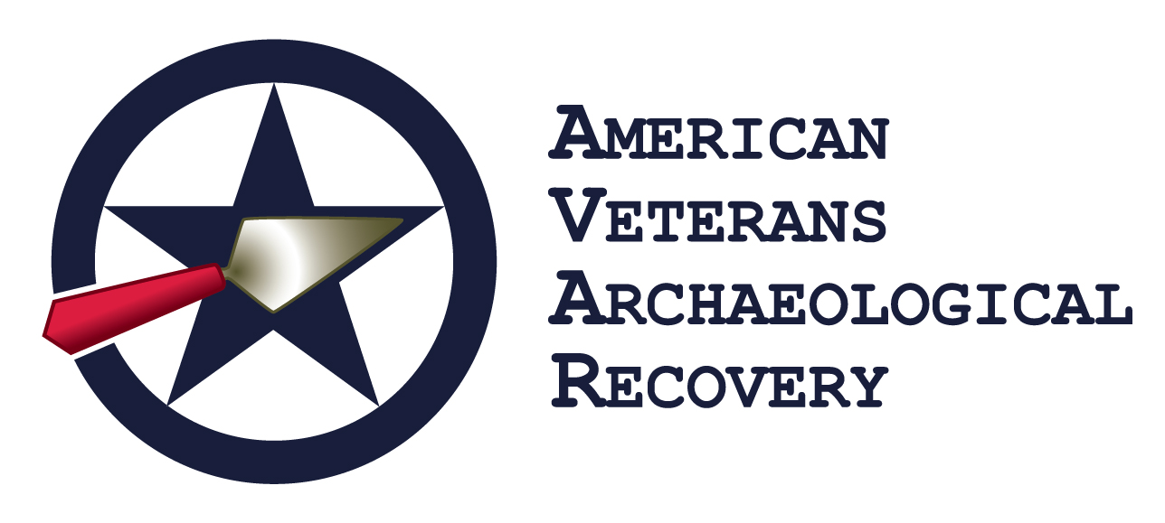
VETERAN PARTICIPANT
AGREEMENT, WAIVER AND RELEASE
1) In consideration of being permitted by American Veterans Archaeological Recovery to participate in activities covered by their mission statement, I hereby waive, release and discharge any and all claims for damage for personal injury, death or property damage which I may have, or which may hereafter accrue to me, as a result of participation in activities through said program. This release is intended to release in advance the American Veterans Archaeological Recovery program, its officers, employees and agents from any and all liability arising out of or connected in any way with my participation in activities at this or any other American Veterans Archaeological Recovery events or facilities even though that liability may arise out of negligence or carelessness on the part of those parties. It is understood that activities such as the ones I will be participating in involve an element of risk and danger of accidents and knowing those risks, I hereby assume those risks. It is further agreed that this waiver, release and assumption of risk is to be binding on my heirs and assigns. I agree to indemnify and to hold harmless, the American Veterans Archaeological Recovery program, its officers, employees and agents from any loss, liability, damage, cost or expense which they may incur as the result of my death or any injury or property damage that I may sustain while participating in any activity at this or any other American Veterans Archaeological Recovery events or facilities.
2) I understand that I may engage in activities that involve risk of loss of property, personal injury, illness or death. I hereby assume all of the foregoing risks and I release, waive, discharge and agree to hold harmless American Veterans Archaeological Recovery and its officers, directors, employees and agents from any loss or liability in any way relating thereto. I unconditionally release American Veterans Archaeological Recovery from any claims for damage, injury, loss, or expense of any nature resulting from events beyond its control, including but not limited to acts of God, war, strikes, crime, terrorism, sickness or quarantine, government restrictions or regulations. This release also applies to any losses arising from the use of any vehicle or from the selection of, or from any act or omission by, any housing agency, host family, travel agency, transportation provider, hotel or excursion provider, host institution, company or individual.
3) I understand that I could be traveling not only within the United States but also to a foreign country, with different customs, standards, laws and risks than I am accustomed to. I understand that my ability to travel between and/or access countries, including the United States, may be postponed, denied or limited due to government laws, regulations, and orders that create restrictions over which American Veterans Archaeological Recovery has no control and no ability to remedy. I understand and acknowledge that (a) I may become sick or injured while participating in an activity, event or program; (b) I may be arrested or imprisoned if I do not conform to local laws; (c) there exists crime in foreign countries and that I may be a victim of crime; and (d) I may not agree with local customs and standards. However, I accept all of the above and described risks and other risks associated with travel in, to and among foreign countries. I understand that I am responsible for exercising caution and common sense at all times, and that American Veterans Archaeological Recovery is not responsible for my safety or acts of third parties and, imposition of governmental restrictions. I agree to release and not hold American Veterans Archaeological Recovery responsible for any such problems I encounter participating in a Program.
4) I understand that as a participant in the program, I will be residing in housing arranged by American Veterans Archaeological Recovery. I also understand that during the program orientation, housing practices will be explained to me, and I will be asked to sign a housing contract. I must agree to abide by the terms of this Agreement and Release, as well as any additional agreements or contracts required during the residency of the Program. In particular, and with respect to housing, I acknowledge and understand that I am solely responsible for my own possessions and the safety of those possessions, and that American Veterans Archaeological Recovery is not responsible for theft or burglary of my possessions, nor is American Veterans Archaeological Recovery responsible for lost or misplaced possessions of mine at any time. I also acknowledge that it is my sole responsibility, relating to my personal possessions that I inquire from my insurance company, whether any particular property or rental insurance policy I maintain, or that are maintained for me, cover my possessions, will be valid in the location of the program, event or facility, and if not, that if I wish for my possessions to be insured, that it is my sole responsibility to deal with insurance providers who will cover my possessions in the location of the event, activity or facility, and it is my sole responsibility to understand, make available, or obtain coverage for my personal possessions in the location of the event, activity or facilities.
5) I understand that as a participant in the program, situations may arise that require my immediate contact, whether that be emergency concerns relating to the program, the foreign country in which the program is situated or, matters relating to my family or other close relationships. I understand that American Veterans Archaeological Recovery, if it needs to contact me relative to such a situation, will utilize reasonable efforts in the circumstances, including e-mail communications and telephonic communications. I acknowledge that American Veterans Archaeological Recovery has advised that all participants should acquire upon arrival at their program destination, local cell phone service which is the only reliable manner to ensure that American Veterans Archaeological Recovery staff can reach participants in the case of an emergency, as Wi-Fi spots for communications in countries abroad may not be as dependable and/or available as in the United States. I also acknowledge, in order to facilitate communication of situations impactful to me, American Veterans Archaeological Recovery requires I share my travel itineraries with American Veterans Archaeological Recovery should I choose to travel independently, away from my program host city, during my American Veterans Archaeological Recovery program stay. It is further understood that American Veterans Archaeological Recovery, if it needs to contact me, will utilize reasonable effort in the circumstances, including email communication and telephonic communication [outreach to other American Veterans Archaeological Recovery program participants, communication with my Emergency Contact and/or my home event, activity and program.] Should I not obtain a local contact number, fail to share my local contact number and/or travel plans with American Veterans Archaeological Recovery or refuse to communicate with American Veterans Archaeological Recovery, I acknowledge American Veterans Archaeological Recovery will not be able to advise or direct me as needed, resulting in potential risk to me.
6) I understand that if I am sick or injured while participating in the program, I authorize American Veterans Archaeological Recovery to take such actions as it considers necessary to secure treatment and/or transportation back to the United States or home of record on file. I release American Veterans Archaeological Recovery from any liability relating to this medical care. I agree to provide the name of an Emergency Contact whom American Veterans Archaeological Recovery may contact should American Veterans Archaeological Recovery deem it necessary. If American Veterans American Veterans Archaeological Recovery incurs any expense on my behalf that is not covered by insurance, I agree to make immediate repayment upon my return. I hereby acknowledge that this application does not create any affirmative duty or responsibility for American Veterans Archaeological Recovery to take any action should I become sick or injured while participating in a program.
7) I will comply with all American Veterans Archaeological Recovery Policies, including its rules, standards, instructions and practices regarding program participation and behavior (including but not limited to the Housing Policy and Alcohol & Drug Policy). I understand that failure to do so may result in disciplinary action up to and including dismissal from the Program. If dismissed, I understand that (a) the cost of returning home is my own expense, and (b) I will not receive a refund of any kind. I understand that my participation may be terminated if I am involved in an incident with civil authorities, or if American Veterans Archaeological Recovery, in its sole discretion, determines that my conduct is incompatible with the safety or welfare of other participants and/or myself, or, in any way undermines the program interests, safety or welfare of other participants. I agree to indemnify American Veterans Archaeological Recovery if I do anything that causes American Veterans Archaeological Recovery to sustain financial loss or liability.
8) I understand that American Veterans Archaeological Recovery advises that all participants to enroll in an insurance plan. I understand that it is advisable to have insurance coverage for my benefit while in the program, including limited health, accident and accidental death insurance. I acknowledge that it is my responsibility to understand the limitations of this coverage and agree that American Veterans Archaeological Recovery is not responsible for any uninsured losses.
9) I understand that American Veterans Archaeological Recovery reserves the absolute right to reject my application or dismiss me from the program if, after acceptance, American Veterans Archaeological Recovery learns of a condition (personal, medical, academic and/or psychological) which in the reasonable opinion of American Veterans Archaeological Recovery may endanger me or others, and/or puts me at risk in a foreign country, and/or shows a history of an inability to adapt to challenging situations, and/or creates or requires burdens and resources not required or necessary to maintain other participants.
10) I understand that American Veterans Archaeological Recovery occasionally uses statements made by its participants and/or photographs and videos featuring them in marketing materials on the web and in print. I consent to such use of my statements or photographs. I agree that I will wear issued American Veteran Archaeological Recovery clothing on designated dates for marketing purposes. I agree that American Veterans Archaeological Recovery may add my name and email address to an email distribution list, which will be shared with other participants in the program during excavations in order to facilitate communications and event coordination.
11) I understand that I am responsible for all transportation costs to and from the project site, to include airfare, airport transfers, etc. unless otherwise specified by American Veterans Archaeological Recovery officers. I understand that American Veterans Archaeological Recovery reserves the right to make changes, cancellations or substitutions to the program for insufficient enrollment, emergency or changed conditions including but not limited to cancellations or changes of partner institutions and security on the ground. I understand that any expenses incurred due to these changes, cancellations or substitutions are at my expense. If I choose to leave the program as a result of these changes, I understand there will be no refund of program fees or of any expenses already paid.
12) I understand that obtaining a passport and any other required travel documents is my sole responsibility. I understand that American Veterans Archaeological Recovery retains the absolute right to reject my application or dismiss me from the program after acceptance, if I am unable to confirm that I possess all appropriate travel documents. In addition, because it is my responsibility to travel legally and possess all necessary travel documents, I will not hold American Veterans Archaeological Recovery responsible at any time relating to my dismissal from the program for insufficient travel documents including costs and expenses associated with my dismissal. By offering participation in these programs, or processing my application, American Veterans Archaeological Recovery is making no representations (verbally or through actions) relative to immigration issues, inclusive of passport or visa issues. I understand that the inability to obtain these visas and other documents does not constitute grounds for a refund or waiving of any program fees.
13) I hereby agree that I will participate to the best of my ability in all designated activities at the American Veterans Archaeological Recovery event to which I have been assigned. I hereby affirmatively state that I am physically able to participate in said activities. I understand that I have been assigned to a project in order to accomplish a scientific research objective, and that I may be removed at my own expense if I refuse to participate in scheduled activities related to the pursuit of that research objective.
14) Any action or suit brought relating to this application or my participation in a program must be commenced and maintained in the appropriate state court, or a Federal district court as applicable. The parties irrevocably consent to jurisdiction and venue in such courts for such purposes and agree not to seek transfer or removal of any action commenced in any such court, and agree that these laws applied irrespective of any conflict of laws analysis. In the event either party hereto institutes an action or other proceedings to enforce any rights arising under this application, the party that prevails in such action, or other proceeding will be paid all reasonable costs and attorneys' fees by the other party. Such fees to be set by the court and not by a jury and to be included in any judgment or award entered in such proceeding.
15) I understand that my participation in this program, which has been organized by American Veterans Archaeological Recovery is contingent on the review and acceptance of my application into the program.
I certify that all of the information I have provided on this application is true and accurate to the best of my knowledge and I agree to inform American Veterans Archaeological Recovery as soon as I learn of any error or change to this information. I understand that any misrepresentation, irrespective of whether innocent or intentional may result of rejection of my application and dismissal from the American Veterans Archaeological Recovery program, irrespective of whether the program commenced or not. I acknowledge that, in making its acceptance decision, American Veterans Archaeological Recovery may rely on the information that I have provided. I have read and agree, through my signature below that all terms and agreements in this application, including but not limited to this Program Participation Agreement and American Veterans Archaeological Recovery policies (application policies, payment policies, on site policies, housing policies, code of conduct policies, and integrity policies) together with any additional policies adopted by American Veterans Archaeological Recovery and applicable during the tenure of the program for which I am applying, are agreeable, are understandable and, this acknowledgement forms a legal and binding obligation/contract. This agreement will be effective as of the date stated below and shall be governed by the laws of the United States.
Print Name ____________________________________________________________ Signature______________________________________________________________ Date___________________________

