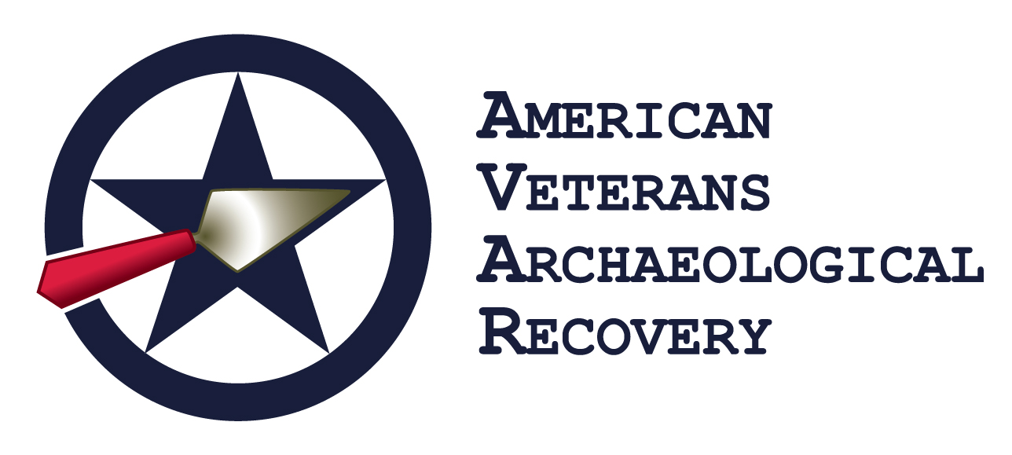

ALCOHOL & DRUG POLICY

American Veterans Archaeological Recovery will not, does not, and cannot provide or condone the use of alcohol or illicit drugs during our excavation programs. We are dealing with participants who may or may not be under medical supervision, who may have been prescribed medications that would adversely interact with alcohol. Some of our participants struggle or have struggled with substance abuse.

Our participants frequently represent the United States Armed Forces on foreign soil, in unfriendly environments. Our participants have been featured in national and international media. The core values of American Veterans Archaeological Recovery call for a representation of the highest ethics and morals embodied by the United States Armed Forces, as we still represent those Armed Forces at home and abroad.

For these reasons, American Veterans Archaeological Recovery has determined that alcohol use and illicit drug use can only jeopardize our reputation as well as the health and wellbeing of our participants. Absolutely, no alcohol, drinking, or intoxication and/or illicit drug use will be allowed at private American Veterans Archaeological Recovery events, activities or facilities. Participants are expected to take medications as prescribed.

If the participant is found not to be in compliance with the American Veterans Archaeological Recovery Alcohol & Drug Policy, disciplinary action up to and including dismissal from the program can occur. If dismissed, the participant will be responsible for the cost of returning home and they will not receive a refund of any kind.

If participants would like information on alcohol or substance use treatment or information on local Alcoholics Anonymous or Narcotics Anonymous meetings, they can request this from any member of staff.

Print Name ____________________________________________________________ Signature______________________________________________________________ Date___________________________

